Matrix based technique

📌 What is Matrix-Based Estimation Technique?
# Source: AI Source: Provided by: [Data Path: Persons Table -> ID Column: 1, Name_En Column: Motasem Essam] -> From: [Chatgpt (GPT‑5 Mini)] on [8/24/2025]
Matrix-Based Estimation is a test estimation technique where the testing effort is estimated by mapping testing activities against influencing factors (like complexity, size, risk, or priority) in the form of a matrix.
👉 In short:
We use a matrix table to assign weights/effort values for different combinations of factors (rows × columns) and then calculate the total effort.

🎯 When to Use
# Source: AI Source: Provided by: [Data Path: Persons Table -> ID Column: 1, Name_En Column: Motasem Essam] -> From: [Chatgpt (GPT‑5 Mini)] on [8/24/2025]
- When the system has many features with different complexities.
- When estimation must consider multiple factors (like functionality type, risk level, test data, environment).
- Works well in test case-based or functionality-based projects.

🗂️ Steps in Matrix-Based Estimation
# Source: AI Source: Provided by: [Data Path: Persons Table -> ID Column: 1, Name_En Column: Motasem Essam] -> From: [Chatgpt (GPT‑5 Mini)] on [8/24/2025]
- Identify estimation factors (e.g., feature complexity, risk, number of test cases).
- Create a matrix with rows = activities, columns = influencing factors.
- Assign weights/effort values for each cell.
- Calculate totals = sum of (weights × factors).
- Adjust for buffer, risks, or rework.

📊 Example: Matrix-Based Estimation
# Source: AI Source: Provided by: [Data Path: Persons Table -> ID Column: 1, Name_En Column: Motasem Essam] -> From: [Chatgpt (GPT‑5 Mini)] on [8/24/2025]
Suppose we are estimating test execution effort for different features.

Step 1: Define complexity categories
# Source: AI Source: Provided by: [Data Path: Persons Table -> ID Column: 1, Name_En Column: Motasem Essam] -> From: [Chatgpt (GPT‑5 Mini)] on [8/24/2025]
- Simple = 2 hrs/test case
- Medium = 5 hrs/test case
- Complex = 8 hrs/test case

Step 2: Build a matrix
# Source: AI Source: Provided by: [Data Path: Persons Table -> ID Column: 1, Name_En Column: Motasem Essam] -> From: [Chatgpt (GPT‑5 Mini)] on [8/24/2025]
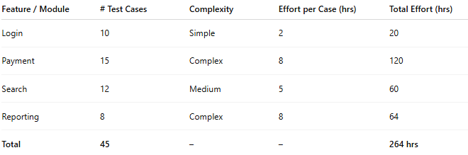
Feature / Module | # Test Cases | Complexity | Effort per Case (hrs) | Total Effort (hrs)
Login | 10 | Simple | 2 | 20
Payment | 15 | Complex | 8 | 120
Search | 12 | Medium | 5 | 60
Reporting | 8 | Complex | 8 | 64
Total | 45 | – | – | 264 hrs

Step 3: Adjust for risk buffer
# Source: AI Source: Provided by: [Data Path: Persons Table -> ID Column: 1, Name_En Column: Motasem Essam] -> From: [Chatgpt (GPT‑5 Mini)] on [8/24/2025]
- Add 10% risk buffer → 264 + 26 = 290 hrs total.

✅ Advantages
# Source: AI Source: Provided by: [Data Path: Persons Table -> ID Column: 1, Name_En Column: Motasem Essam] -> From: [Chatgpt (GPT‑5 Mini)] on [8/24/2025]
- Structured and transparent estimation.
- Easy to explain to stakeholders.
- Can handle multiple factors (complexity, priority, risk, environment).
- Works well when test case counts are available.

⚠️ Disadvantages
# Source: AI Source: Provided by: [Data Path: Persons Table -> ID Column: 1, Name_En Column: Motasem Essam] -> From: [Chatgpt (GPT‑5 Mini)] on [8/24/2025]
- Needs detailed inputs (test cases, complexity, etc.) → not useful very early in project.
- Can become time-consuming if the matrix is too large.
- Accuracy depends on realistic weight assignment.

🔑 Summary
# Source: AI Source: Provided by: [Data Path: Persons Table -> ID Column: 1, Name_En Column: Motasem Essam] -> From: [Chatgpt (GPT‑5 Mini)] on [8/24/2025]
- Matrix-Based Estimation uses a matrix table of factors × activities to calculate testing effort.
- Useful when features have different complexities, priorities, or risks.
- Provides structured and reliable effort estimation.

